OFFICIAL COORDINATION REQUEST FOR
NON-ROUTINE OPERATIONS AND MAINTENANCE

COORDINATION TITLE- 23JDA05 Floating Orifice Gate Removal
COORDINATION DATE- 21 March 2023
PROJECT- John Day Dam
RESPONSE DATE- 4 April 2023

Description of the problem - The John Day South (JD-S) fishway has an auxiliary water supply (AWS) powered by three turbines which feeds water to the entrance area of the JD-S fish ladder. Each turbine design is complex and consists of a turbine, gear box, and the pump itself.
The JD-S fishway was dewatered on 1/17/23 for annual winter maintenance. During an oil change of the gear box of South fish turbine #3, metal shavings were found in the filter.
Upon draining 70 gallons of oil from the gearbox to inspect the gears and bearings, additional metal shavings and fragments were found on the bottom of the gearbox. Representatives from the Philadelphia gear company inspected the gear box on 22 February and determined the input shaft gear bearing to be the cause of the metal and recommend it be replaced before more significant damage occurs to other internal components. Upon review of recommendations from the Philadelphia gear company and concurrence from JD project maintenance staff, South fish turbine #3 will be forced out of service until repairs can be made to the input shaft bearing in the gear box. It’s determined that the gearbox is too unsafe to operate in its current condition and operating it will cause more permanent damage to the internal gearing of the gearbox and could eventually catastrophically fail.
On 28 February the John Day South fish ladder was returned to service for the beginning of the adult fish passage season. Fish turbine pumps 1 & 2 were commissioned and put into service at 1500 and the adult ladder was meeting all FPP requirements. On the morning of 1 March mechanics and operators, during routine inspections, noticed excessive vibration coming from fish turbine pump # 2. It was determined the pump was unsafe to operate and that continuing would cause significant damage. Therefore, the pump was forced out of service at 0930 on 1 March. John Day maintenance has determined the cause of the vibration to be excessive wear on the lower guide bearing on the pump assembly of South fish turbine pump #2. The bearing was pulled out and journaled to reattach Teflon guide strips for the intermediate propeller shaft. Currently the bearing is being reattached to the pump assembly and the fish turbine pump is expected to return to service by 20 March.
Two JD-S AWS turbines are required to be in service to meet the full FPP criteria, with one remaining as a back-up. The FPP provides operational guidance for AWS turbine failures. With turbines #2 & #3 out of service, John Day Fisheries moved into a 1 turbine operation per the FPP as follows: 3.2.4.1.b. If two turbines fail, operate the adult fish facility as follows until a fishway head of 1' is achieved:
i. Increase discharge of remaining unit to maximum capacity.
ii. Close NE-1.
iii. Leave NE-2 at a depth of 8’.
iv. Close remaining floating submerged orifice gate entrances starting at north
end.
v. Leave south powerhouse entrance weir (SE-1) at 8’ depth below tailwater
surface.
vi. If criteria are still not achieved, reduce entrance weirs depth to 6’, then to 4’ if
necessary, until more auxiliary water is available. Then reverse the above
procedure.

Ladder operation, from 1 March until present, followed the FPP guidelines for 1 turbine operation.
- South entrance weir 1 and North Entrance weir 2 where submerged at 8’,
- North Entrance weir 1 was closed and floating orifice gates were removed.
- Ladder entrances were within the 1’-2’ range and within FPP criteria.
- Collection channel velocities averaged 1.7 feet per second in the South fishway.
- South fish turbine pump #1 output was set at 68 rpms.

South Fish turbine 2 returned to service on the afternoon of 20 March. JDM noticed increased vibration while running the unit to its normal operating setting of 68 rpms and immediately decreased the output to 55 rpms.

Currently the South fish ladder is operating with:
- North entrances 1 & 2 open, and weirs submerged at 8’with 1.7’ of head differential.
- The South entrance is operating with the weir submerged at 8’ with a head differential of 1.4’.
- Collection channel velocities are averaging 2.6 feet per second.
- South fish turbine pumps 1 & 2 are set at 55 rpms each.
- All floating orifice gates are removed.

Type of outage required – 2 Floating orifice gates will be removed until South fish turbine #3 is returned to service. The additional water savings will aid in decreasing the output of fish turbines 1 & 2 and will help by decreasing any degradation to the unit’s pump assemblies, which are in poor shape and at risk of total failure.

Impact on facility operation – The 2 additional floating orifices will be removed from the South end of the powerhouse leaving the 2 entrances on the North end of the powerhouse and the 1 entrance on the South as the primary ladder entrances into the fishway.

Dates of impacts/repairs Starting 21 March 2023 and continuing until fish turbine 3 returns to service.

Length of time for repairs TBD JDA is awaiting a detailed quote with timeframes for repair

Analysis of potential impacts to fish-
Pulling the floating orifice gates from units 1 & 2 could possibly cause slight upstream migration delays for some adult salmon populations due to fewer entrance options.

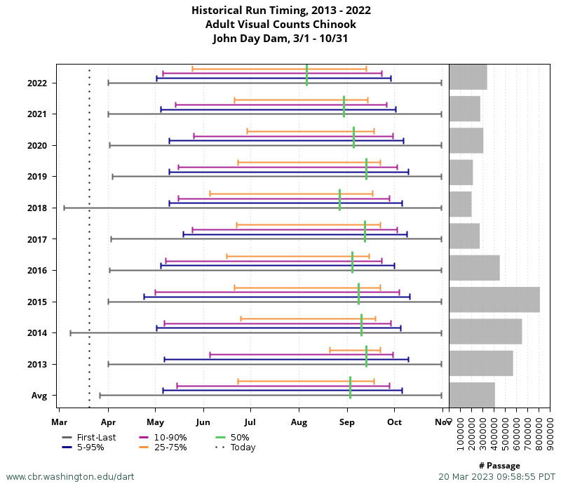
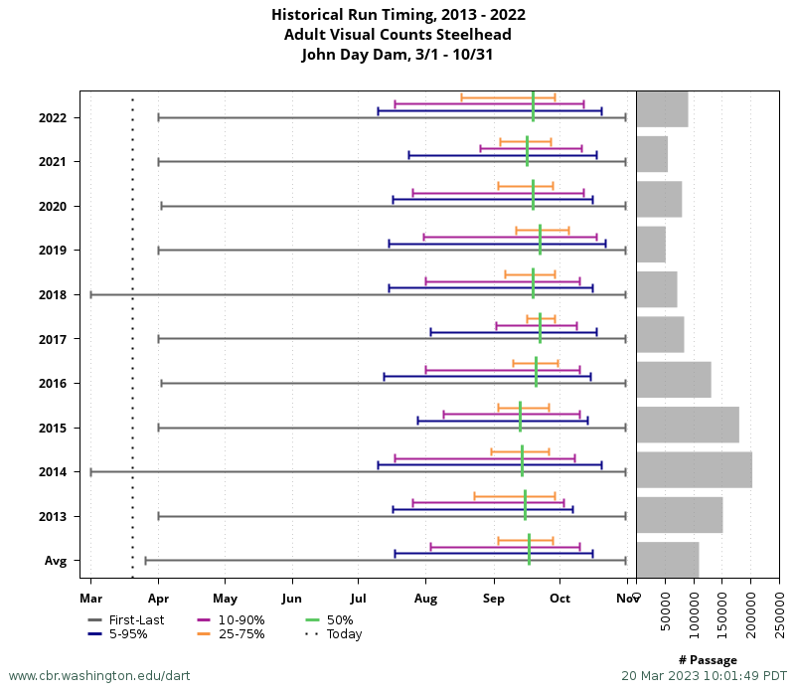
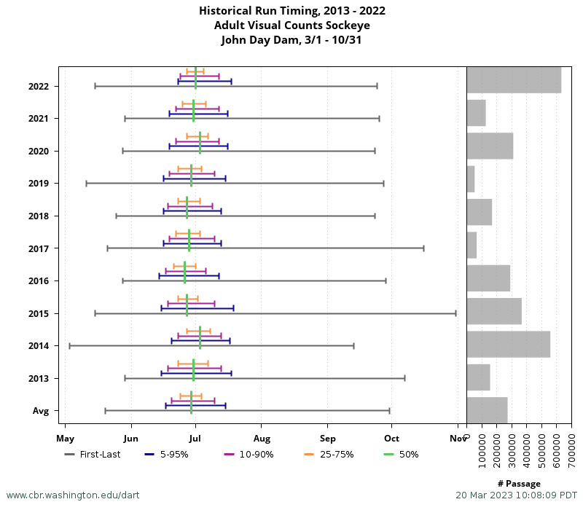
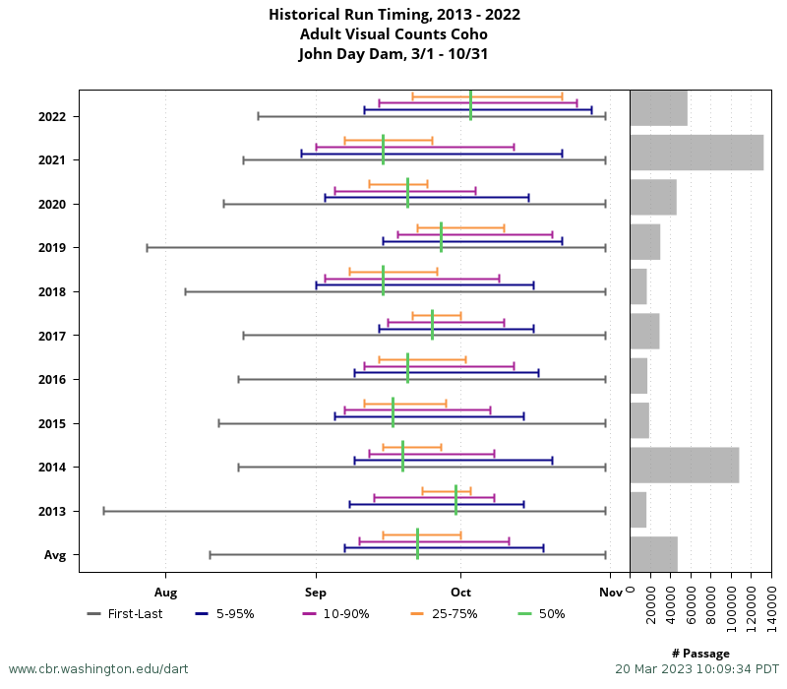
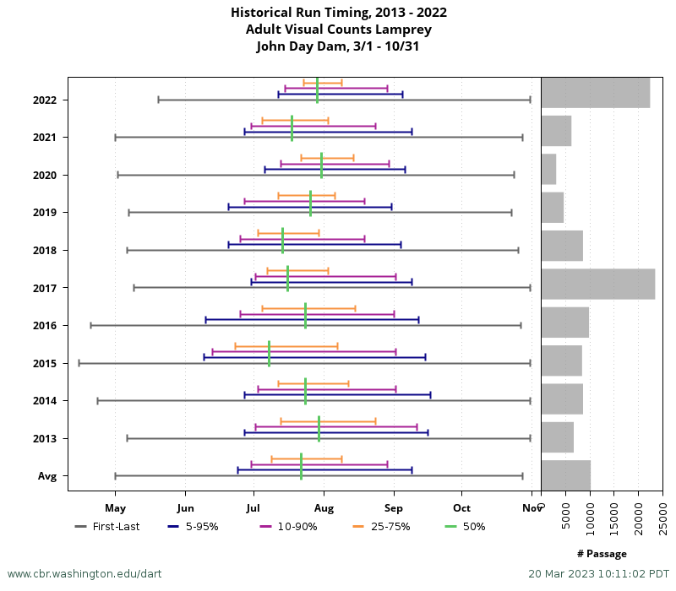

- 10-year average passage by run during the period of impact for adults and juvenile listed species, as appropriate for the proposed action and time of year;
- Statement about the current year’s run (e.g., higher or lower than 10-year average);
- Estimated exposure to impact by species and age class (i.e., number or percentage of run exposed to an impact by the action);
- Type of impact by species and age class (increased delay, exposure to predation, exposure to a route of higher injury/mortality rate, exposure to higher TDG, etc.);

Summary statement –

The condition of South fish turbine pumps 1 & 2 gives the project no flexibility in maintaining entrance criteria at the ladder entrances if the floating orifices are redeployed.

Comments from agencies

Final coordination results

Please email or call with questions or concerns.
Thank you,
Tammy Mackey

Tammy.m.mackey@usace.army.mil
503-961-5733

